

laB 02

[Document subtitle]



[Date]

[Company name]

[Company address]

**TASK 01:**

**1.**

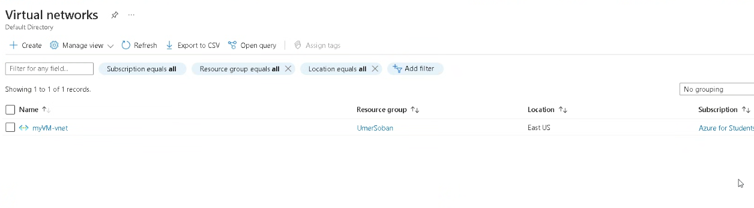

**2.**

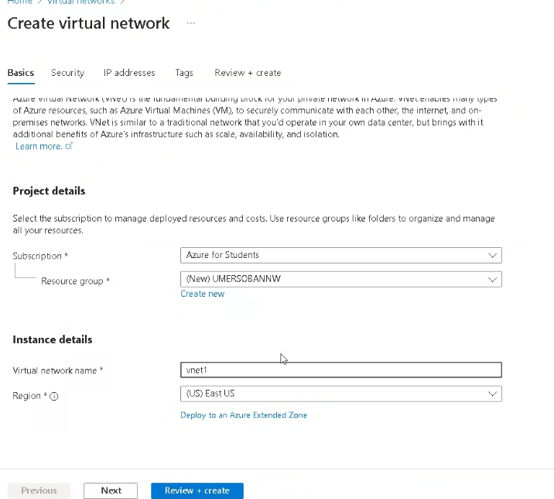

**3.**

**4.**

**TASK 02:**

**1.**

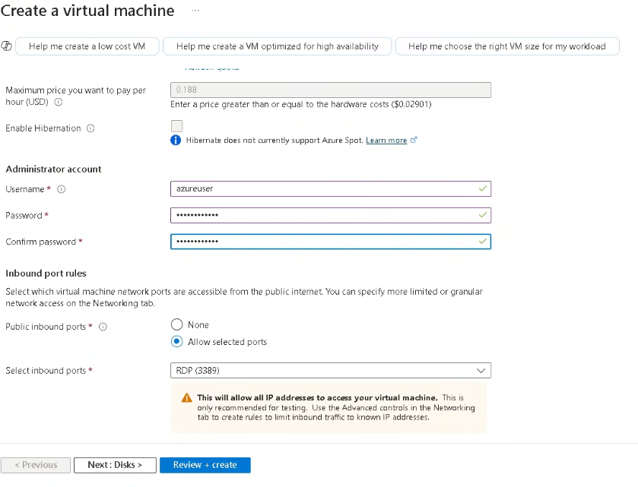

**2.**

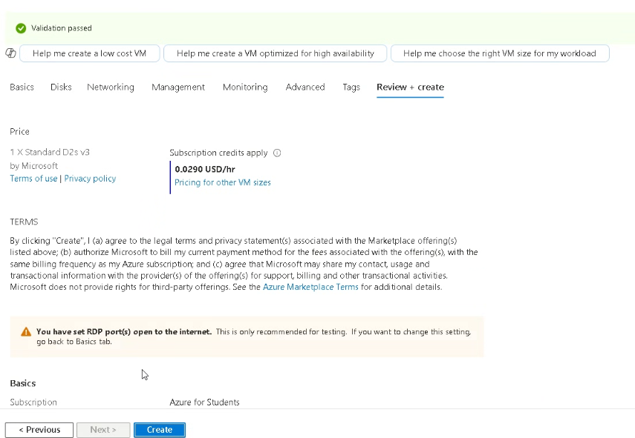

**3.**

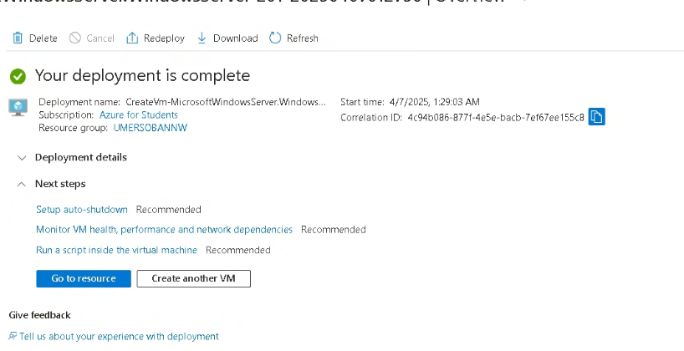

**4.**

**  
TASK 03:**

**1.**

